Technical Report

Project Exam 1 – Re-sit

Jan Emil Gustafsson

Word count

Summary: 266 | Main text:596

Table of Contents

1. Summary 3

2. Body 4

2.1. Introduction 4

2.2. Main section of report 4

2.3. Conclusion 4

3. References 5

4. Acknowledgements 6

5. Appendices 7

# 1. Summary

This Course Assignemt has been a challenging one with many new things to learn. I overall feel I have learnt a lot, but I have been lacking the time I needed to be completely happy with the end result. We took over out new house this week and as you may know there is a lot of work moving houses. The first week of the CA I tried my best to work between the packing, but the last week was allmost all consuming with the move. We didn’t get notice untill a few weeks prior to moving in, so we were unsure when our move was scheduled to. In addittion our internet service provider is not up and running untill the 8th of october due to installment delays so I've tried to make the best of it with 4g conection but the service at the new place is pretty bad. All of this has impacted my work for this CA and I have really tried my best to come up with a stable enough website to be delivered.

Aside from this the CA and course as a whole was very interesting. I have had what feels like prior experience to this subject as I usually find some way products would have been better in my opinion, so learning this in depth has been quite interesting. Working with personas, storyboards and Adobe XD was quite enjoyable. So this CA report will include my previous submissions for MA´s and a link to the Adobe XD prototype as well as a link to my version of the Letha webpage.

# 2. Body

## 2.1. Introduction

Included in this CA is my previous MA submissions for this course with my reports on the particular Module Assignments and my processes. I have really enjoyed this course as I feel on a personal level I have been looking at things this way for some time, but never used in any practical way. Learning how to extract personas out of the material gained trough interviews was a fun experience though demanding in the present situation worldwide. Making storyboards was also a good experience, though I cant really draw I feel the points are getting trough.

When we got around the Adobe XD MA I got exited as I felt it was a really great tool to build prototypes. It was a bit of a learning curve but I think I got a handle of the essentials. I felt pretty happy with the prototype in the end and as you can see from my webpage it impacted a lot of the choices I brought from the prototype.

You can look past the text from my MA´s if that is not applicable for the CA, I only wanted to give the report the full scope of my previous thoughts and submissions if the reader wanted that information.

## 2.2. Main section of report

**Were starting of with my report on the MA1 submission below:**

**Module Assignment 1 – Interaction Design**

For: Jan Emil Gustafsson

March PT 2019

**Lesson Assignment 1.2:**

During this assignment I learned the value of observing your subject/partner to assert how and why you should do this kind of research. It was a fun and teaching experience. As you can see I have chosen four people for my personas and built upon my results of those interviews. It was a bit demanding to complete due to the corona crisis, but I feel I managed to capture some of the essence of the task.

As you can see I have included photographs of my notes and persona builds as I went along.

I learned how important it was to do research and was surprised at how much can be missed when you don’t to research like this.

In building my personas I chose people I knew about to make sure I got a bit of diversity. I hope my notes are readable enough, as I made them on paper.

As I was picking through my notes to find the pain points I found it easier to mark the pain points in a similar colour throughout my notes so I could easily find them later.

The pain points were not many, as the personas had some experience but I managed to weed out some that will be very important later in the course I feel.

**Lesson Assignment 3.1:**

As you can see here I have included the images from lesson 3.1.

This lesson taught me a lot about the building of scenarios and how much work it is when you do it all by yourself, so I can imagine doing a task like this in a group would be a lot more efficient and with a lot more depth, insight and more ideas as you can toss ideas back and forth with the other people in the group. That said it was a demanding but good experience to have been trough. It will undoubtedly help to know about it when entering into a job.

I made my scenarios on paper so I hope they are readable and don’t contain to many typos but I felt it was more effective to continue working in that line as with the other LA´s. I have certainly learned that these things take time and concentration to complete.

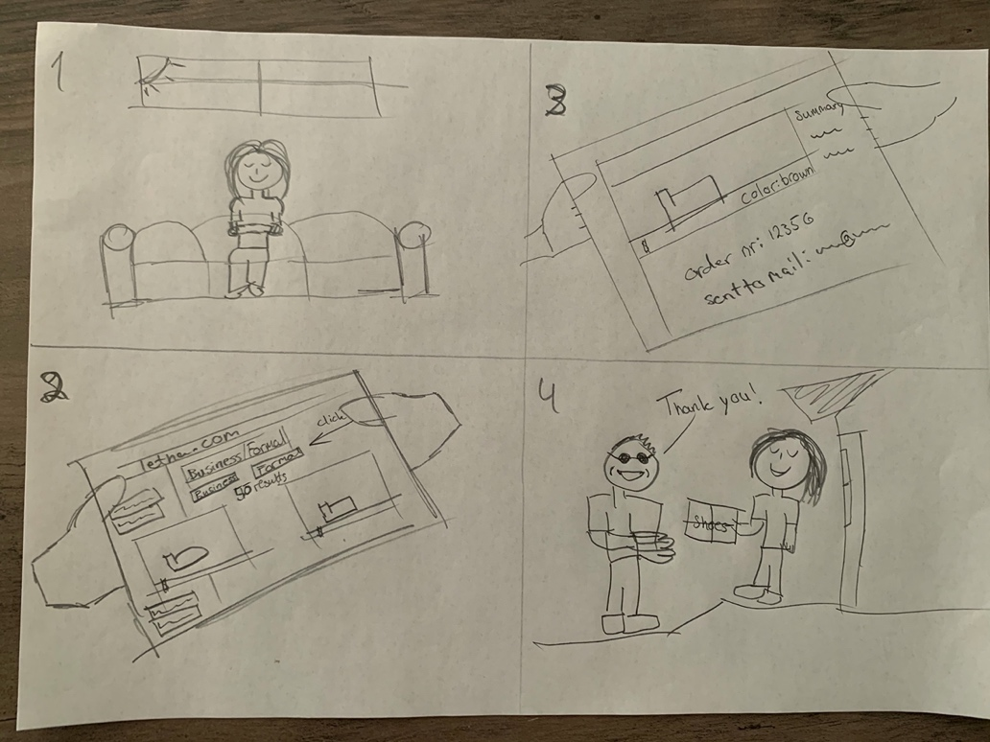

**Lesson Assignment 4.1:**

As you can see here I have included the images from LA 4.1.

I had my fiancée look over and test the build and I got some feedback that I adjusted before the final delivery. I incorporated numbers on the yellow labels so you could see which page you were sent to as you “clicked” them. I feel it could have been better and more immersive but this Lesson Assignment has been huge, with lots of information and work to absorb.

I would certainly use the experience in making these types of prototypes in further work. They give a lot more usability testing then just drawing or making mock-ups as you can “interact” with the pages.

**Were continuing with my report on the MA2 submission below:**

**Module Assignment 2 – Interaction Design**

For: Jan Emil Gustafsson

March PT 2019

To highlight the different parts of this Module Assignment I have chosen to incorporate the assignment descriptions in the delivery to highlight the different tasks of the assignment. Continued on the next page we start off with the LA 2.3 card sort.

**Lesson Assignment 2.3**

**Card Sort:**

For the card sort task I asked my fiancée to help me sort the cards using closed card sort/hybrid card sort. I gave her a set of 32 cards to sort, most of which were already written out with page names/categories and around 6 that were blank for her to fill inn if she felt something was missing.

During the card sort I tried staying out of the ordering and only gave tips if I saw one of the cards were a bit unclear. There were luckily only a few cards that ended up in this category and one that got left out.

During the card sort I really learned how one should categorize and how important and valuable this process can be, as I learned by watching the cards end up in a totally different composition from what I had in my head. Most of the feedback gave more sense as I saw it laid out and differed from my view, and some I needed a bit of explanation to conceive but I could see it made better sense.

I’m attaching a photo of the card sort and the order of which they were placed. As you can see each card has a number and name/category which will help me down the road when making comparisons to future card sorts with the same cards. Upon this I can build my statistics and form my webpage in a way that can suit expert users as was the case for this card sort, and for future card sorts with intermediate and beginner’s participation.

The best learning experience I got from this assignment was that I as a developer can really broaden my views and horizon when it comes to planning a webpage. Previously I have only planned a page as I would like it presented and thought that my view/plan would be sufficient for nearly everyone, but this really opened my eyes to take in how important usability testing and Interaction design is. As you can see from the picture below, my build of the webpage is a quite different from how the card sort turned out.

Although the card sort doesn’t completely cover the entire build of the site it gives me strong indicators of how I can implement a more user centered solution for the webpage.

**Information Architecture:**

As you can see from the information architecture below, I have made a hierarchical view over the most necessary pages that the website must include.

There is of course more detail on the pages outlined but it would seem cluttered as I noticed this when making it. But on the product image as suggested from the card sort I have included the price and the shoe color options where multiple colors are applicable. In the product detail page there is a size chart and the aforementioned price and color. After the user clicks on order here a dropdown with shoe sizes and sizes in stock appears in a dropdown so that the customer can see if their size is in stock, this creates flow trough the order process and the customer can see the progress as they go trough the process. After the user has selected their size if applicable the order here button will be highlighted to show that they can proceed and are taken to the order form. The order form has a checkbox the customer can check if they want their information saved for future purchases and an email will be sent to them with the choice to sign up for a customer account reliving them of the task to do that at the purchase time. When the customer is finished with the form and the form validation has accepted the entries (if not, specific labels on the fields informs what is missing) they will be taken to the delivery options, shipping time estimates and shipping cost will be informed. They will also have an option at the end to check of a box for gift wrapping in which case the checkbox gets checked they get a few options for gift wrapping, if not checked no options or action needs to be taken. They can then proceed to click the checkout button, which when clicked will take them to the checkout confirmation page with information such as “a confirmation of your purchase has been sent to your email”, a reference number and an estimated time of delivery. Also “Thank you for your order, we hope to see you again” will be at the end.

I fell all these steps will ensure a good customer experience and hopefully a satisfied customer as they receive their order.

**Persuasive techniques:**

When it comes to using USP´s, the LETHA webpage differs from a lot of webpages selling shoes as they make and sell “Handcrafted men’s footwear”. This in itself is a “Unique selling point/ Unique selling proposition” in my mind. This shows that they are willing and conveys a self confidence in their products in that they remove big segments from their products (women and children) and that they also choose to instill a specific age range in their products show that they have a well thought out market segment as their target. This can be a good point to highlight in the making of the logo and include a strong confident brand with the words “Handcrafted men’s footwear” included in the logo and/or header and marketing material.

As for a marketing technique with a small portion of persuasiveness one might incorporate a sales pitch which gives they buyers a “buy three, get the cheapest at 50% off”. I have noticed that this works very often when it comes to myself, and can give the customer a need to fulfill the task of buying three instead of two as the three will complete the task of fulfilling the required three.

One might also incorporate a gift card reward for purchases above 200$ as to make the customer feel as they have received a reward for their purchase.

When it comes to call-to-actions some of this is included in the ordering process as they are continually forwarded and given a flow to complete the purchasing process. One might also incorporate this in the product image on the homepage to include a one click buy option for registered users who are done with the sign up process and/or are repeating customers. The easiest way to do this I think is to have the option appear for them as they sign in and give them a choice to opt in to that function and not have it as a necessity.

**Were continuing with my report on the MA3 submission below:**

**Module Assignment 3 – Interaction Design**

For: Jan Emil Gustafsson

March PT 2019

I**ntroduction**

For this module assignment we were given the task of building workable prototypes for both desktop and mobile in Adobe XD for the Letha homepage. It was a fun but demanding experience to learn how to use Adobe XD and all its tools, I think there’s still much to learn but I can really see the good capabilities this software offers. I have tried to incorporate and build the prototypes with the personas and users in mind. I have gotten some feedback during the process which made me rethink and use other solutions.

**Main section**

Link to module assignment 3, part 1, Letha homepage desktop prototype: <https://xd.adobe.com/view/b20767a8-555d-409e-a9a6-ac3afd4f9e51-e754/>

Link to module assignment 3, part 2, Letha homepage mobile prototype:

<https://xd.adobe.com/view/0566dbd1-071d-4fc7-bf9a-85d3db06bd3f-5035/>

As I read the MA assignment I saw that we were given the task to build the prototype for desktop first, and reading further down I saw we should build a mobile prototype too. I then decided to build for mobile first as we have learned that this is good practice when working with javascript, html and css webpage design.

I decided not to use much time on making a logo for this task, but I will be sure to make one later as I´m not completely satisfied with the look of the header/logo incorporated in this prototype design. But I chose to use colors I feel resonate with the look of leather and leather products, in this instance shoes.

Building the desktop version I first used a grid with a view if different products and incorporated the buttons I had created for the mobile version in a navigation down on the left side. I got some feedback that the use of these buttons and the grid with product examples drew attention away from the navigation so I incorporated big call to action images/buttons instead to not overwhelm the user. I took use of shadows and familiarity in the design of the buttons to highlight the buttons. For the navigation bar in the header I used rounded corners to accentuate the look and feel of buttons.

I have incorporated many images in the design with the use of creative commons resources from the plugins in Adobe XD. This is because almost all webpages I have viewed in the past and during this module incorporate a lot of images to accentuate their products and what they offer on their sites.

As you can see there are more pages and a bit more diversity in the mobile design prototype. This is due to it being smaller and a bit harder to make room for all navigation on the homepage.

In the desktop version there was more room for big call to actions, as an example the large sale image which leads directly to the page containing products for sale. As you can see I have also tried to make the site a little less cluttered when you navigate away from the home page and incorporated the categories into a dropdown menu. I feel this is good practice and give the users a better experience when browsing around the pages. I’m not sure if I did it correctly but you can get the general feel and idea of it in the prototype.

I also tried adding a hover state to my buttons, but I was not able to figure this out at this time, or else I would have incorporated hover states to all clickable elements which I find is good practice on webpages.

I have provided the links for both the desktop and mobile prototype at the start of this report and at the bottom to make it the readers choice to watch the prototypes as they read or after they have read the main section of the report.

Link to module assignment 3, part 1, Letha homepage desktop prototype: <https://xd.adobe.com/view/b20767a8-555d-409e-a9a6-ac3afd4f9e51-e754/>

Link to module assignment 3, part 2, Letha homepage mobile prototype:

<https://xd.adobe.com/view/0566dbd1-071d-4fc7-bf9a-85d3db06bd3f-5035/>

**Conclusion**

This module has been a lot of fun in spite of there being a lot of new things to learn in using Adobe XD. I had some issues when trying to download and make use of the UI kits from Apple, but I think I managed in the end. There is not really that much explaining about how to “install” the UI kits in the Adobe XD video, and in searching for videos on how to use them the sources seemed mostly outdated. But I found a way to get use of them. I tried to incorporate the things we have learned throughout the module, but its hard remembering all of the terms and ICT solutions but I think I’ve managed to incorporate it in the design. I really look forward to learning and using Adobe XD in the future and hope I can master it better in the future.

**Were concluding with the CA report on building the website for Letha homepage:**

Beginning this CA as stated earlier was a bit of a challenge for time on my part as it has been a hectic couple of weeks. But I started working on it the very first chance I got after receiving the CA. I started looking around the web for a good bootstrap option as I saw there were a lot of options out there. As some time went on I realized we have not been allowed to use bootstrap on earlier submissions, but that hadn’t been mentioned in this CA overview so I hurried onto Discord to ask one of the teachers if we were allowed. At my great relief we were welcome to use bootstrap in this submission so I forged on with my started webpage. As the days went on I saw that the time I had left at the end of the days of packing and sorting out the move to our new house was a bit short for my liking. I ended up working into the late hours of the night and still I was short on time as I also needed sleep. Then the moving week came and time was even sparer, but I continued to work when I had time.

Onto my thought on the webpage. I started out with the prototype thinking I wanted a masculine look on the pages and convey the look of leather. As I saw this worked well in the Adobe XD prototype I continued the use of the same colour theme in the design of the webpage. As the bootstrap provided a more similar vision to what I wanted then the Adobe XD prototype I changed some of the components from the prototype. I feel these work better and give the page a more interactive feel. As I received feedback on the buttons I had used in the prototype I decided to use colour to enhance rather than pictures, by doing this I feel it gives the page better interaction and a crisper cleaner design.

I continued the use of call to action images/buttons at the top to invite the user in and to catch the eye better with the use of the bootstrap carousel. This is something I have seen used a lot previously and feedback from people who tested my page said this was a nice way to draw the eye to the categories, sale, seasonal and gifts rather then have them in the top menu.

As you can see my design is not complete. As explained earlier I have tried to design it in a way that you can see how and where my thought process was getting to, so I hope there is enough to convey my vision.

## 

## 2.3. Conclusion

Working with this CA and course was as stated fun and eye opening in the sense of being more and more aware of the thought that lie behind good design and interaction design. Many real world examples lack a lot of these principles in their design, but it seems the world of users are upping their demands in the quality of their products. So businesses have to keep up and design for good interaction for users and not for what they think is best.

The webpage I have submitted is not complete as I feel it lacks the touches I could have put in had I had enough time. But I´m happy with the lessons I have learned from this CA and the course as a whole.

# 3. References

# 4. Acknowledgements

**Bootstrap acuried from:**

Copyright 2013-2020 Start Bootstrap LLC. Code released under the [MIT](https://github.com/StartBootstrap/startbootstrap-shop-homepage/blob/gh-pages/LICENSE) license.

[2020-09-27_I-D_CA_Jan_Emil_Gustafsson_Report.pdf](https://lms.noroff.no/pluginfile.php/17732/assignsubmission_file/submission_files/156656/2020-09-27_I-D_CA_Jan_Emil_Gustafsson_Report.pdf?forcedownload=1)

# 5. Appendices

Adobe XD Good Food Mood mockups:

Link to mobile mockup:

<https://xd.adobe.com/view/f6084666-d238-44e6-a5a2-ef6d203ba21b-a35b/>

Link to desktop mockup:

<https://xd.adobe.com/view/a2f8f0ae-8f1f-4928-8649-9d56e50e9f91-f7ab/>

Link to Course Assignment, Letha webpage:

<http://goosefront.com/2020-09-27_I-D_CA_Jan-Emil-Gustafsson/letha_website_bootstrap/startbootstrap-shop-homepage-gh-pages/>